**DEPARTMENT OF ELECTRONICS & COMMUNICATION ENGINEERING**



**ANALOG IC DESIGN**

**EXPERIMENT 7**

**Submitted to, Submitted by,**

**Dr. Arun Kumar T Raja Aadhithan**

**Asst. Professor 602162021**

**M.Tech (VLSI Design)**

**Experiment: Differential Amplifier with active load**

**Aim:**

To implement a differential amplifier of gain 100 with active load and analyze its transient characteristics.

**Tool Used:**

LTspice

**Theory:**

Differential amplifiers apply gain not to one input signal but to the difference between two input signals. This means that a differential amplifier naturally eliminates noise or interference that is present in both input signals.

For a NMOS, PMOS let’s assume

VT = 0.4V

VDD = 1.8V

Kn = 120µA/V2 ,

Kp = 120µA/V2 ,

Which implies

r01 = 1/ lambdan*ID  = 200Kohm

r02 = 1/ lambdap*ID = 400Kohm

Which gives the value of Rout to be 133.33 Kohm

Which gives a value of (W/L) = 46.8 for 50uA ID.

Hence with this value of W/L we get a VGS of 0.533V

**Circuit Schematic:**

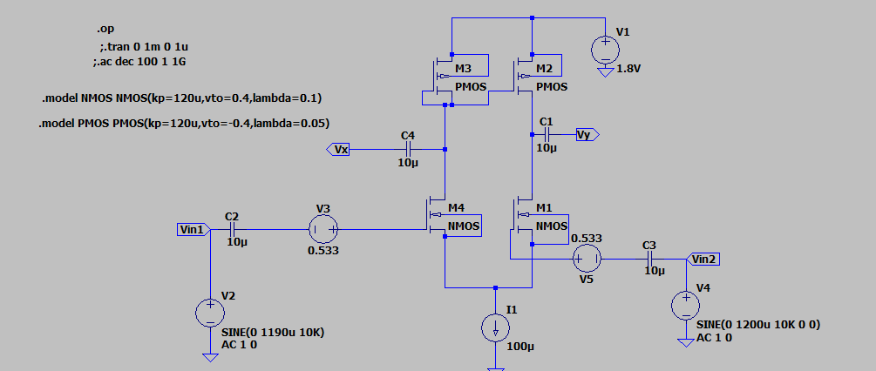

**Output Waveforms:**

**--- Operating Point ---**

**V(n001): 1.8 voltage**

**V(n002): 0.525487 voltage**

**V(n003): -0.51144 voltage**

**V(vy): -5.11435e-006 voltage**

**V(n007): 0.533 voltage**

**V(n004): -0.525412 voltage**

**V(vin1): 0 voltage**

**V(n005): -0.532995 voltage**

**V(n006): 5.32995e-006 voltage**

**V(vin2): 0 voltage**

**V(n008): 0 voltage**

**V(vx): 5.25482e-006 voltage**

**Id(M4): 4.88105e-005 device_current**

**Is(M4): -4.88105e-005 device_current**

**Id(M1): 5.11894e-005 device_current**

**Is(M1): -5.11894e-005 device_current**

**Id(M3): 4.88105e-005 device_current**

**Is(M3): -4.88105e-005 device_current**

**Id(M2): 5.11895e-005 device_current**

**Is(M2): -5.11895e-005 device_current**

**I(C4): 5.25482e-018 device_current**

**I(C3): 0 device_current**

**I(C2): -5.32995e-018 device_current**

**I(C1): 5.11435e-018 device_current**

**I(I1): 0.0001 device_current**

**I(V5): 0 device_current**

**I(V4): 0 device_current**

**I(V3): -5.32995e-018 device_current**

**I(V2): -5.32995e-018 device_current**

**I(V1): -0.0001 device_current**

Transient characteristics

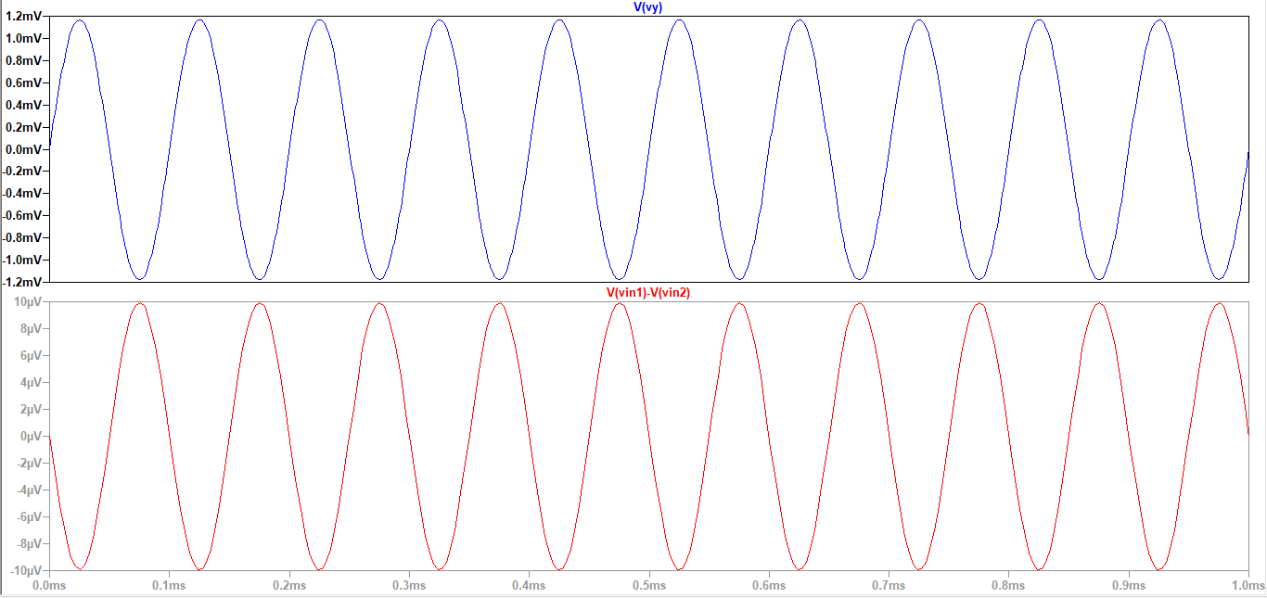

**Result:**

The circuit is designed for a gain of 100 and the output is verified to be correct.